**Session-6 Assignment**

**Name :-** Aryan Dilipbhai Langhanoja

**Enroll No :-** 92200133030

**AIM**: To analyze VI characteristics of Zener Diode and design voltage regulator.

.

**Objective:**

1. To analyze forward and reverse bias characteristic of Zener diode.
2. To understand need of load and line regulations.
3. To build and analyze Zener voltage regulator.

**Apparatus:**

1. Zener Diodes 1N4738A
2. 220 Ω Resistor
3. DC power Supply
4. DSO/Multimeters

**Task-1 VI characteristics of Zener Diode: (simulate in Multisim, plot using excel)**

**You can also plot characteristics manually on simple graph paper.**

**Take an image of it and submit in canvas.**

**Sample Circuit diagram:**

|  |  |
| --- | --- |
| Image result for zener diode forward characteristics circuit | Image result for zener diode forward characteristics circuit |

**Simulation circuit in Multisim: (Take screen shot of your circuit and paste here)**

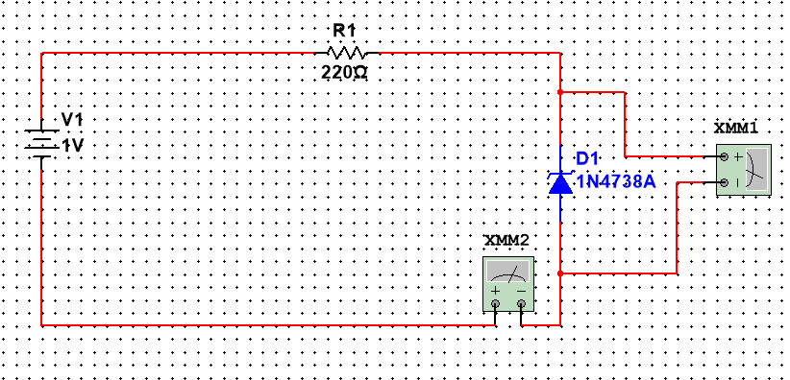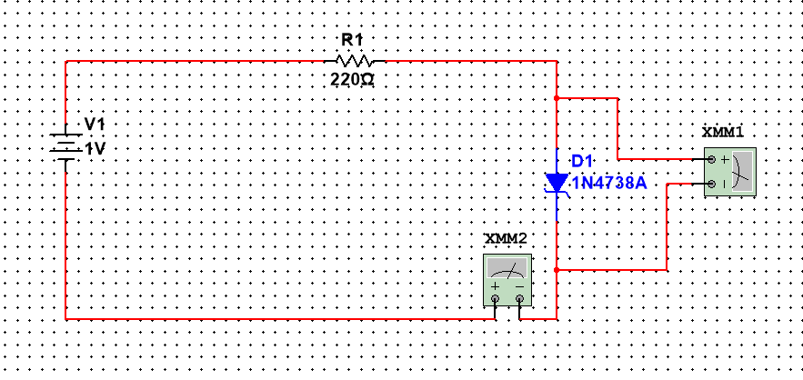

**VI Characteristics curve:-**

**VI Characteristics curve: (Take screen shot or image of manual work and paste here)**

**Forward bias characteristics:**

**Reverse bias characteristics:**

**Observation Table:-**

Forward Bias:

|  |  |  |
| --- | --- | --- |
| **Supply Voltage**  **Vs (Volts)** | **Diode Forward Voltage Drop**  **Vd (Volts)** | **Diode Forward Current**  **Id (mili-ampere)** |
| 0 | 0 | 0 |
| 0.1 | 0.1 | 0.00003 |
| 0.2 | 0.199 | 0.0001 |
| 0.3 | 0.299 | 0.0005 |
| 0.4 | 0.385 | 0.014 |
| 0.5 | 0.426 | 0.073 |
| 0.6 | 0.445 | 0.154 |
| 0.7 | 0.457 | 0.242 |
| 0.8 | 0.465 | 0.334 |
| 0.9 | 0.472 | 0.427 |
| 1 | 0.477 | 0.522 |
| 1.1 | 0.481 | 0.618 |
| 1.2 | 0.485 | 0.714 |
| 1.3 | 0.488 | 0.811 |
| 1.4 | 0.491 | 0.908 |
| 1.5 | 0.494 | 1.006 |

Reverse Bias:

|  |  |  |
| --- | --- | --- |
| **Supply Voltage**  **Vs (Volts)** | **Diode Reverse Voltage Drop**  **Vd (Volts)** | **Diode Reverse Saturation Current**  **Is (micro-ampere)** |
| 0 | 0 | 0 |
| 1 | 0.999 | 0.001 |
| 2 | 2 | 0.002 |
| 3 | 3 | 0.003 |
| 4 | 4 | 0.004 |
| 5 | 5 | 0.005 |
| 6 | 6 | 0.006 |
| 7 | 7 | 0.007 |
| 8 | 7.99 | 9.509 |
| 9 | 8.108 | 892.03 |
| 10 | 8.127 | 1872 |
| 11 | 8.138 | 2862 |
| 12 | 8.146 | 3854 |
| 13 | 8.152 | 4848 |
| 14 | 8.157 | 5843 |
| 15 | 8.161 | 6839 |

**Task-2 Zener Diode as Voltage Regulator (Line Regulation): simulate in Multisim**

**Circuit diagram:**

Keep RL = 500 Ω 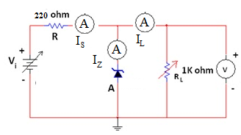

**Simulation circuit in Multisim:**

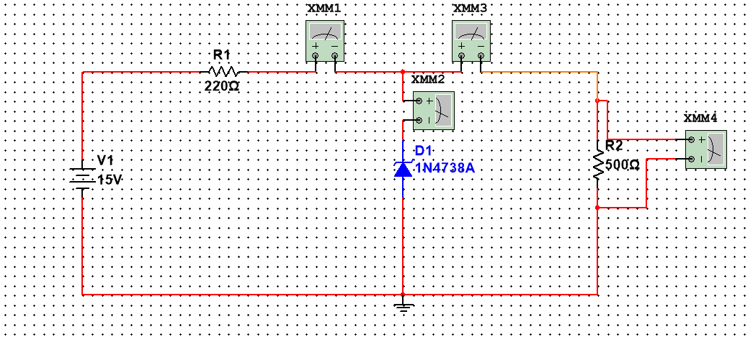

**Observation:**

|  |  |  |  |  |
| --- | --- | --- | --- | --- |
| **Vi** | **Is** | **IZ** | **IL** | **VR­L = Voutput** |
| 0 | 0 | 0 | 0 | 0 |
| 1 | 1.389 | 0 | 1.389 | 0.694 |
| 2 | 2.778 | 0 | 2.778 | 1.389 |
| 3 | 4.167 | 0 | 4.167 | 2.087 |
| 4 | 5.556 | 0 | 5.556 | 2.778 |
| 5 | 6.944 | 0 | 6.994 | 3.472 |
| 6 | 8.333 | 0 | 8.333 | 4.167 |
| 7 | 9.722 | 0 | 9.722 | 4.861 |
| 8 | 11.111 | 0 | 11.111 | 5.556 |
| 9 | 12.5 | 0 | 12.5 | 6.25 |
| 10 | 13.889 | 0 | 13.899 | 6.944 |
| 11 | 15.278 | 0 | 15.278 | 7.639 |
| 12 | 17.638 | 1.389 | 16.239 | 8.12 |
| 13 | 22.018 | 5.706 | 16.312 | 8.156 |
| 14 | 26.496 | 10.154 | 16.342 | 8.171 |
| 15 | 30.998 | 14.638 | 16.638 | 8.18 |

**Plot Graph:**

**Input voltage vs Output voltage Graph (Vi 🡪 VRL):**

**Input voltage vs Zener diode current Graph (Vi 🡪 Iz ):**

**Task-3 Zener Diode as Voltage Regulator (Load Regulation): simulate in Multisim**

**Circuit diagram:**

Keep VI = 12 V 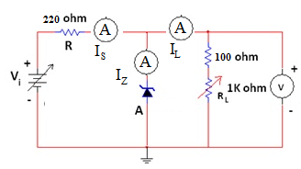

**Simulation circuit in Multisim:**

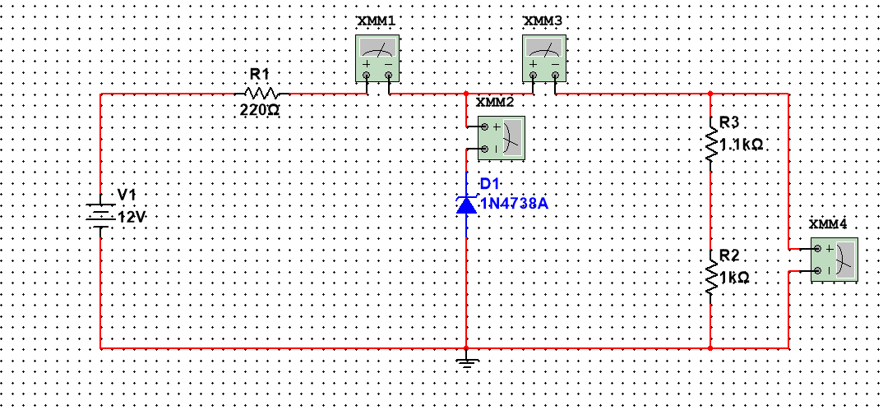

**Observation:**

|  |  |  |  |  |
| --- | --- | --- | --- | --- |
| **RL** | **Is** | **IZ** | **IL** | **VR­L = Voutput** |
| 100 Ω | 17.407 | 9.979 | 7.428 | 8.17 |
| 200 Ω | 17.4 | 10.59 | 6.81 | 8.172 |
| 300 Ω | 17.395 | 11.107 | 6.287 | 8.173 |
| 400 Ω | 17.39 | 11.151 | 5.839 | 8.174 |
| 500 Ω | 17.386 | 11.936 | 5.45 | 8.175 |
| 600 Ω | 17.383 | 12.273 | 5.11 | 8.176 |
| 700 Ω | 17.38 | 12.57 | 4.81 | 8.176 |
| 800 Ω | 17.378 | 12.835 | 4.543 | 8.177 |
| 900 Ω | 17.375 | 13.071 | 4.304 | 8.177 |
| 1000 Ω | 17.373 | 13.285 | 4.089 | 8.178 |
| 1100 Ω | 17.372 | 13.477 | 3.894 | 8.178 |

**Plot Graph:**

**Load Resistor vs Output voltage Graph (RL🡪 VRL):**

**Conclusion:**